Things That Pass a Thousand Times:
Unearthing Hestercombe’s Collections

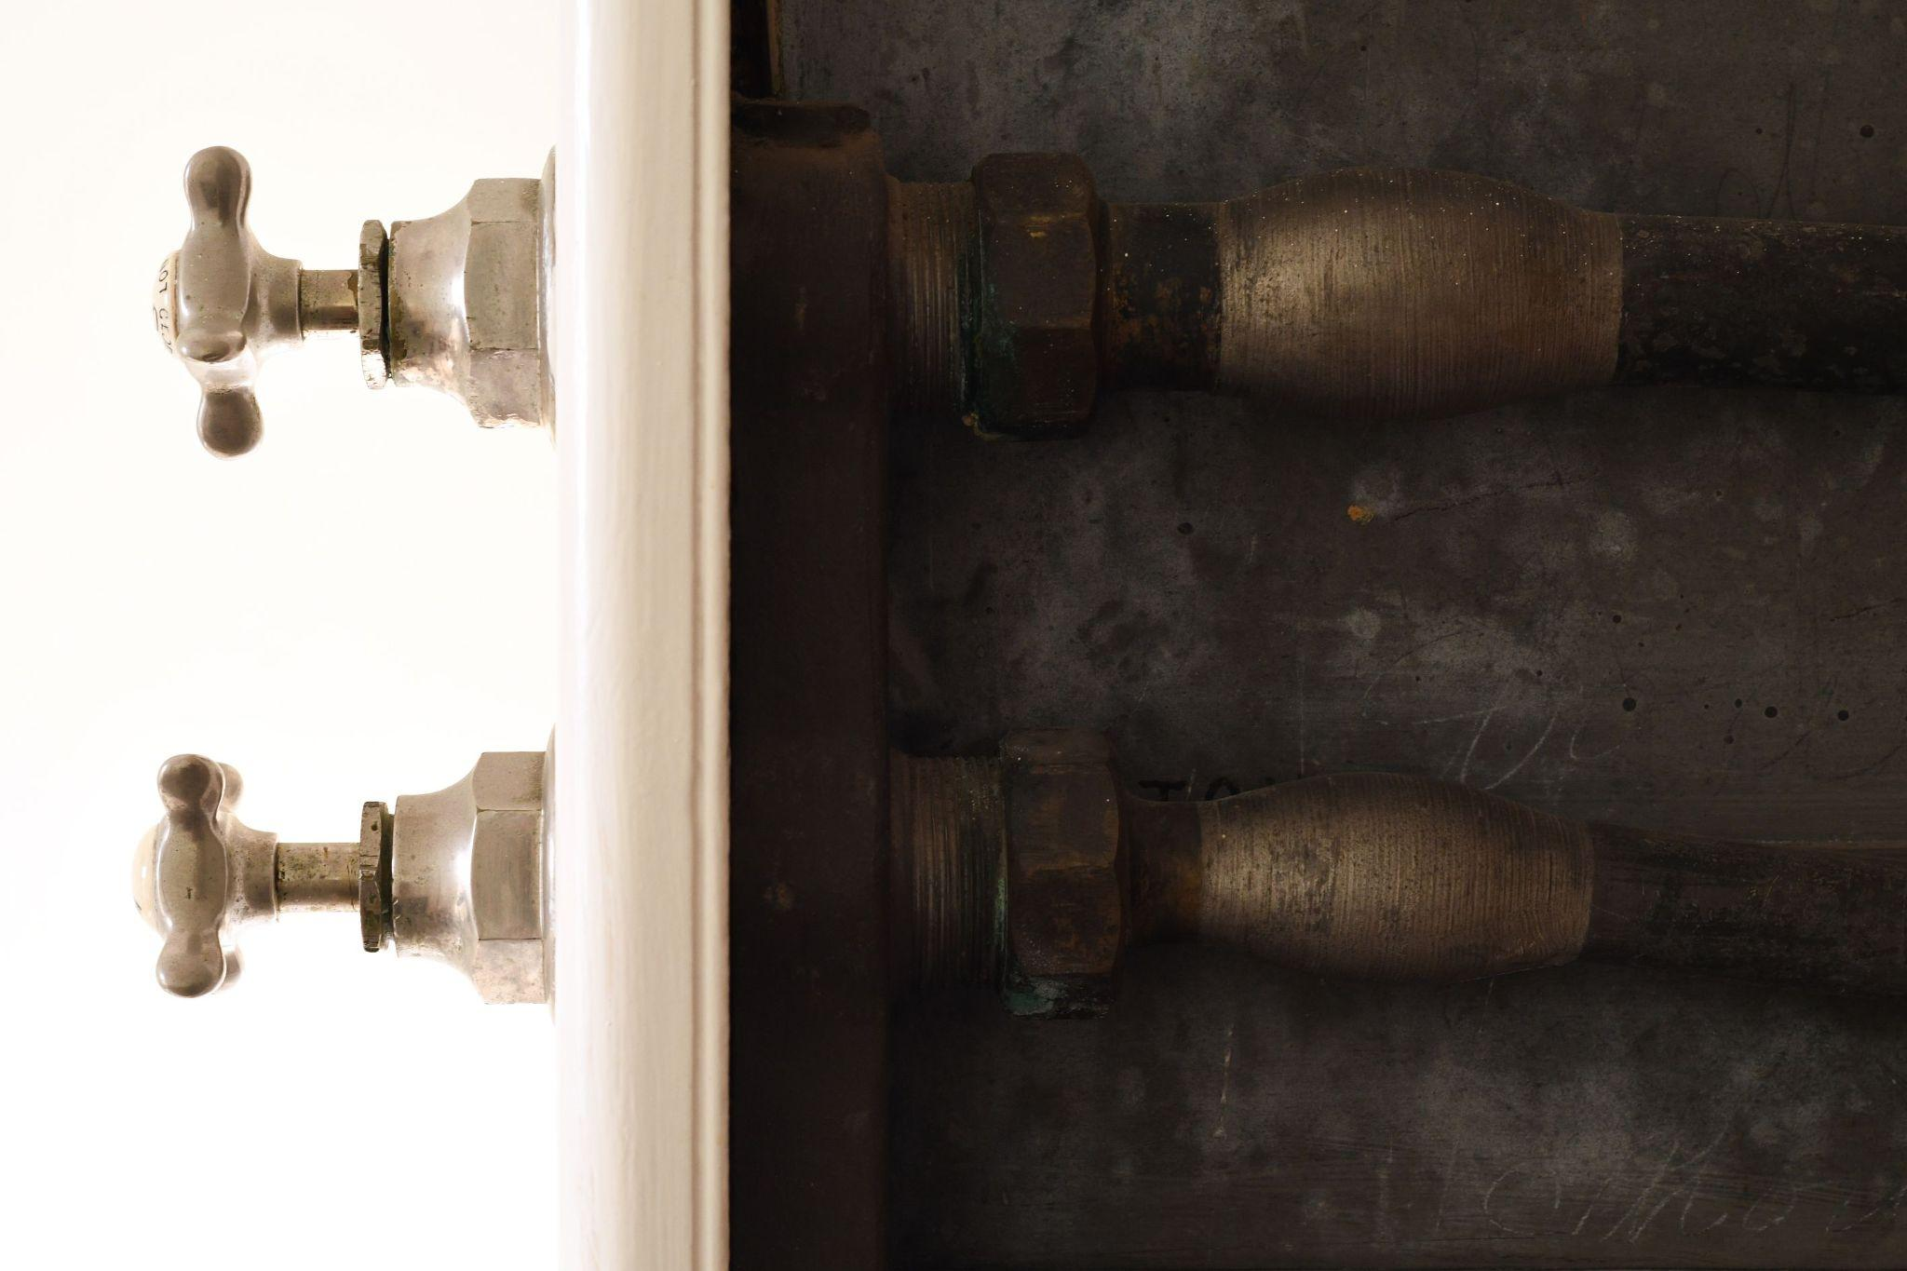
Credit: George Jennings Ltd. .designed bath belonging to Hestercombe’s Victorian owners Mr and Mrs Portman (detail), photographer: Jon England.
Download high-resolution images
For the first time ever, Hestercombe will display never-before-seen objects from its archives, showcasing an array of items spanning across five-hundred years - from the key that unlocks the Warre family chest to Gertrude Jekyll’s trowel - revealing a treasure trove of history.
Showing from 12th March - 15th May 2022, visitors will have the opportunity to unearth some of the greatest works and artefacts from Hestercombe’s vast collections, which is made up of over 2,200 objects and over 10,000 references. Audiences will be able to explore the trust’s rich history and delve deep into Hestercombe’s past through paintings, drawings, sculpture, poetry, photographs, rare books, archaeological finds and many more.

Things that Pass a Thousand Times: Unearthing Hestercombe’s Collections, is a title which takes inspiration from poet and artist the Reverend John Eagles, a much-loved 1st cousin of 19th century owner Miss Warre, and frequent visitor to Hestercombe. Audiences will be able to unearth the objects and stories of the people that shaped Hestercombe’s past and present.

The exhibition comprises seven unique galleries, which take visitors on a themed journey from the seventeenth century to the recent restoration of the eighteenth-century landscape garden. The rooms are all centred around four key themes; portraits, possessions, pictures and poetry. Early photographs, rare books, film, paintings and drawings, archaeological finds and personal mementos expand on these motifs.

Some of the highlights include: the 17th Century Warre family money chest and the original key to open it; a haunting portrait of the young Francis Warre before his untimely death; a notebook dated back to 1663, which contains the jottings of Miss Margaret Bampfylde; recently acquired C. W. Bampfylde watercolours; photographs revealing the eccentric jacuzzi bath of Hestercombe’s victorian owners, the Portmans, which is still perfectly preserved in Hestercombe House; Teddy Portman’s game records and the picnic set he took on his hunting trips; Gertrude Jekyll’s original trowel and sketchbook; finds excavated whilst restoring the Elizabethan Water Garden and Victorian technologies; and original manuscripts and volumes from a hundred years of poetical links, or more specifically, the poetry that inspired the title of this exhibition.
Philip White, Chief Executive of Hestercombe, commented:
“We’re delighted to be able to share some of Hestercombe’s hidden treasures from our vast archives. The exhibition compliments a larger project we are currently working on to become an accredited museum.
“Being granted official museum status would ensure that our nationally significant collections are officially recognised, which means that we are able to make them more accessible for everyone. With our extensive collection protected, Hestercombe will have the status to access further funding for our conservation work; to showcase archives with more digital content and to further develop community projects.

“The process began in 2018, but as an organisation we have been collecting, safeguarding and making objects accessible since the Trust was created. Through sharing our nationally significant collections, we can tell the stories of the people who have made Hestercombe what it is today. Showcasing such important artefacts also helps us look to the future; to the artists who are inspired to explore the history and heritage of Hestercombe to make contemporary work in Hestercombe Gallery.”

Things that Pass a Thousand Times: Unearthing Hestercombe’s Collections will take visitors on a journey through time, with the array of quirky items in the exhibition telling the stories of those who have lived, worked and visited Hestercombe, since the first written record of the estate from an Anglo–Saxon charter of 682 to the present day.

ENDS

FURTHER INFORMATION
To contact the Press Office please email heatherchristian@hestercombe.com
Download high-resolution images here

Facebook
Twitter
Instagram

Open daily, 10am – 5pm
Hestercombe Gallery
Cheddon Fitzpaine
Taunton
Somerset
TA2 8LG
hestercombe.com/whats-on/unearthinghestercombe

Notes to editors

Hestercombe Gallery
Hestercombe Gallery opened in 2014 with the aim of showcasing the best in contemporary arts practice. Seven years on from its opening, Hestercombe Gallery has delivered a programme of high quality exhibitions in reclaimed spaces, a series of artists in residence, outdoor commissions as well as an engagement programme including talks, seminars and workshops involving artists, students, academics, teachers and experts from other disciplines.

hestercombe.com/art-gallery

